Adobe Experience Platform Schema Design Identities, Relationships & Union Profile View

UI Lab

Contents

0](#_Toc109296542)

Lab Overview 1

Learning Objectives 1

Lab Resources 1

Lab Tasks 1

1.0 Declare an identity & a Primary Identity 1

2.0 Build relationships between two schemas 2

3.0 Enable a schema for profile 3

4.0 Inspect your union schema View 4

# Lab Overview

Learn how to set an identity & a primary identity so that you can build relationships between a profile and a lookup schema. Enable schemas for profile to inspect the union schema view.

# Learning Objectives

**What should you walk away with after taking this Lab?**

* Declare an identity
* Declare a primary identity
* Build a relationship between two schemas
* Enable a schema for profile & inspect union schema view

## 1. Declare an identity & a Primary Identity

You completed the creation of the *Customer Account Schema* in the UI schema lab. To complete schema config, you must mark the identities that you determined during the “I” step of the SID lab, and build a relationship. Finally, you must enable the schema for profile.

**Mark the Personal Email Address Field as an identity.**

1. **Open** your customer account schema
2. **Select** the *personalEmail.address* field
3. **Mark** the identity checkbox on the right rail
4. **Select** the *Email* identity namespace from the dropdown.

1. **Apply & Save** your changes. Validate that a thumbprint shows on your field.

**Mark the customer ID Field as a primary identity.**

1. **Select** the *_dxp.customerID* field.
2. **Mark** it as identity and primary identity using the checkboxes on the right rail
3. **Select** the *customerID* namespace from the dropdown. Graphical user interface, text, application, chat or text message

   Description automatically generated
4. **Apply & Save** your changes. Validate that a thumbprint shows on your field.

You have completed the assignment of identities on your *Customer Account Schema*.

­

## 2. Build relationships between two schemas

Build a relationship between your *Customer Account Schema* and the *Plan* schema.

1. **Select** the*PlanID* fieldon the *Customer Account Schema*
2. **Check** the relationship checkbox on the right rail
3. **Select** the reference schema: *dep: Lookup Plan*

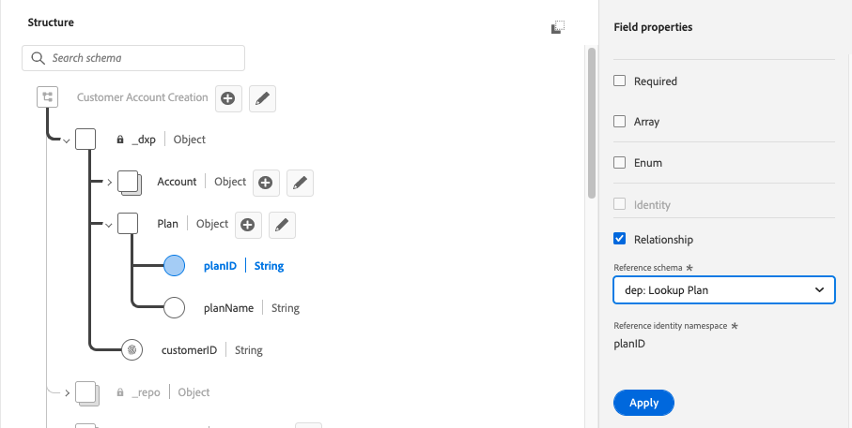

|  |  |
| --- | --- |
| Note | When building a relationship, you don’t need to specify the destination property. The primary identity on the destination schema will be used. |

1. **Select** Apply *&* Save. Validate you see the relationship between planID and the dep: Lookup Plan Schema



## 3. Enable a schema for profile

Real-time Customer Profile merges data from disparate sources to construct a complete view of each individual customer. If you want the data captured by a schema to participate in this process, you must enable the schema for use in Profile.

1. **Open** your Customer Account schema.
2. **Enable** your schema for profile by toggling on the profile toggle on the right rail, and selecting enable

1. **Save** your schema

## 4. Inspect your union schema view

1. **Navigate** to **Profiles** on the left navigator
2. **Select** the **Union Schema** tab on the top menu
3. **Select** your individual profile class

1. Notice the schema shown is an aggregate merged view of all profile schemas in your sandbox. Some auto provisioned AJO schemas are included.
2. Browse Unions of different classes to see the union for Experience Event and Specific Lookup classes.